|  |
| --- |
|  |

|  |
| --- |
| **Cloud Native and Mobile web computing** |
| Learning by doing |
|  |
| Document on Cloud Native and Mobile web computing, learning by doing basis. Prepare by Noman ul Haq |
|  |
| **Noman ul Haq** |
| **4/30/2020** |
|  |

# Cloud Native and Mobile web computing

## Monolithic Computing

* Traditional way/ architecture of computing is also known as **monolithic computing**
* As a definition monolithic means is
  + Very large, united and difficult to change
* A monolithic architecture is traditional unified model for the design of a software program
* Monolithic, in this context means composed all in one piece
* Monolithic software is design to be self-contained meaning having all that is needed, in itself

### Traditional way of computing

* Components/ layers of the program are interconnected and interdependent
* In a tightly couple architecture, each component and its associated components must be present in order for code to be executed or compile.
* Application is too large and complex to fully understand and made changes fast and correctly
* You must redeploy all application on each update
* The size of application can slow down the startup time of application
* Another problem is reliability. Bug in any module can potentially bring down the entire process
* Monolithicic application has barrier to adopting new technologies. Since changes in frameworks or languages will effect an entire application it is extremely expensive in both time and cost

## Microservice Architecture

* The microservice architecture style is an approach to developing a single application as a suit of small services
* Each runs in its own processes and communicates with lightweight mechanism, often an HTTP resource API

Microservice do have distinct advantages:

1. Better Organizing:
   * Microservice architecture are typically better organized
   * Each microservice has a very specific job to perform, and it is not concerned to job of other components
2. Decoupling:
   * Decoupled services are also easy to change, update and re-configure to serve the purposes of different apps
   * They also allow for fast independent delivery of individual parts within a large, integrated system
3. Performance:
   * Under the right circumtances, microservices can also have performance advantages depending on how they are organized
   * It is possible to isolate hot services and scale them independently of the rest of the app

Table of Contents

Cloud Native and Mobile web computing 1

Monolithic Computing 1

Traditional way of computing 1

Microservice Architecture 1

What is Cloud? 3

Types of Cloud 3

What is Cloud Native? 3

DevOps 4

## What is Cloud?

* In a single line cloud can be describe as a “communication network”
* The cloud often refers to the internet, and more precisely to some datacenter full of servers that is connected to the network
* A cloud can be a WAN, like the public internet or a private, national or global network. The term can also refer to al LAN within an organization

### Types of Cloud

#### Public Cloud

* A cloud computing service available on internet to the general public
* Commercial cloud providers like Amazone, Google, Azure, etc.

#### Private Cloud

* Deploying cloud computing internally
* Private cloud employs cloud computing within a company’s own LAN or WAN network

#### Hybrid Cloud

* The use of both public and private clouds to provide an organizations computing needs

## What is Cloud Native?

* Cloud Native Computing Foundation (CNCF), is the organization which maintain standard and gathered people under one platform.
* Cloud Native Computing Foundation (CNCF), which is an open source software foundation dedicated to making cloud native computing universal and sustainable, describe cloud native as, *“cloud native technologies empower organizations to build and run scalable application in modern, dynamic environments such as public, private and hybrid clouds”*
* Other definition of Cloud Native Computing could be: *“An approach that build software applications as microservices and run them on a containerized and dynamically orchestrated platform to utilize the advantage of cloud computing model”*
* Cloud native is about **HOW** application are created **NOT WHERE**
* Cloud native app development typically includes:
  + DevOps
  + Agile methodology
  + Microservices
  + Cloud computing programs
  + Containerize application
  + Orchestration system
  + Continues integration/ continued development
* In short every new and modern method of application deployment

## DevOps

Developer cum operations

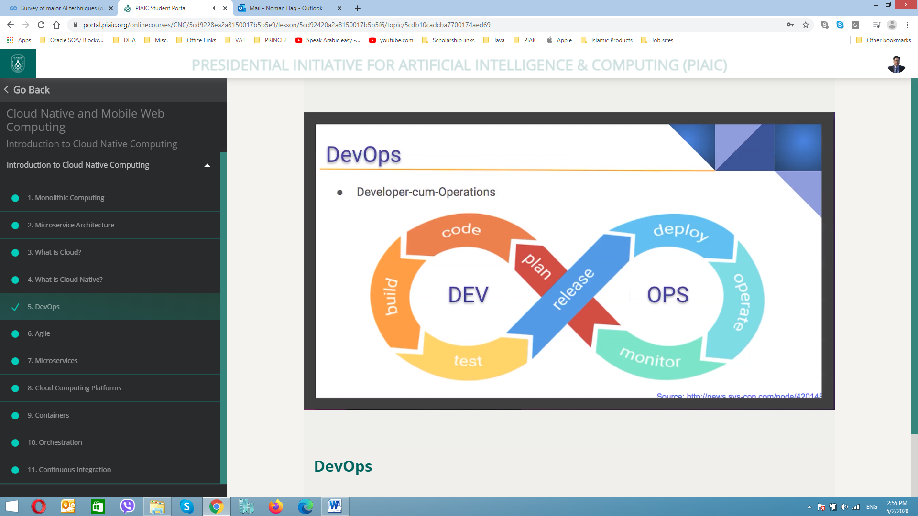

* Plan > Coding > building (executable and deployable form) > test (error free) > release (handover build code to operation team) > deploy (application will run on server) > operates > monitor (is there any problem, bug or anything which can be eliminated from the system
* It is called a continues face
* Developer will perform all above tasks by himself by using of different tools and techniques.

## Agile

* Before agile development there was water fall methodology adopted means until unless all project is completed it will not deploy.
* In agile technologies tasks are distributed in micro projects
* Agile technology is described as “iterative” and “incremental” approach
* Agile developer visualize the software as a combination of complex parts that interacts with each other rather than large block of structure
* Actually in water fall method, development team will get only single chance to get each phase (like design, development, testing etc.) of the project
* Whereas in agile methodology, these phases are continually revisited periodically to identify/ understand the project’s progress and direction
* The inspect and adopt approach from agile methodology, greatly reduces development cost and time to market the product because here team can develop the software while gathering changes the requirements
* The stakeholders can provide feedback to the development team to improve the quality of the product
* Agile development does save lot of resources which could have spent on something not needed anymore

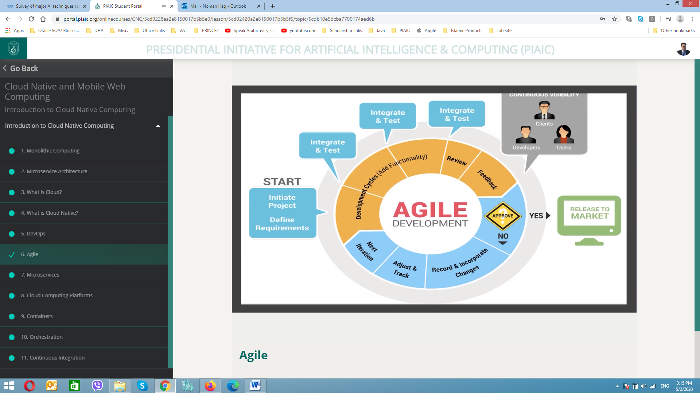

## Microservices

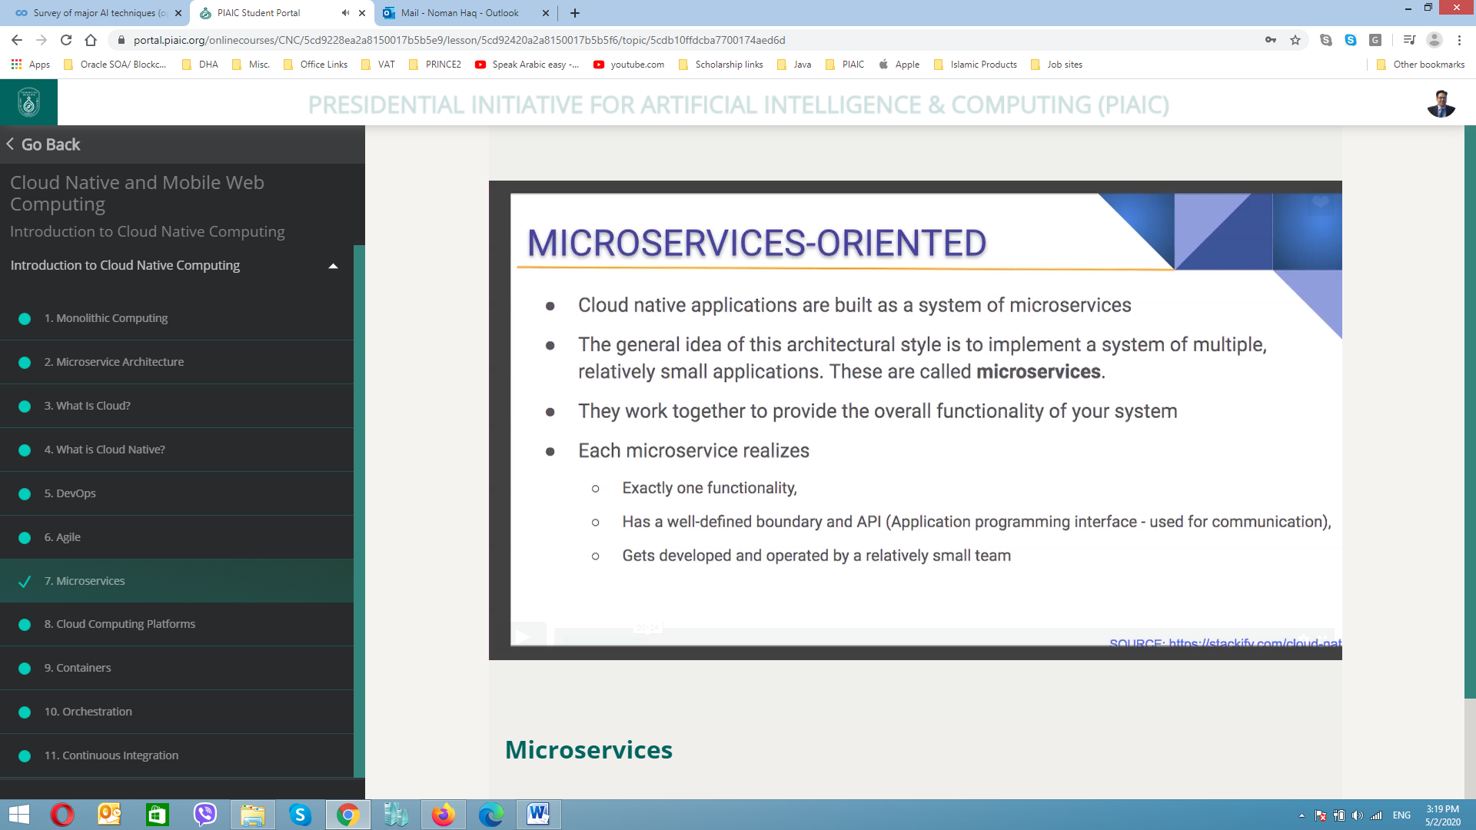

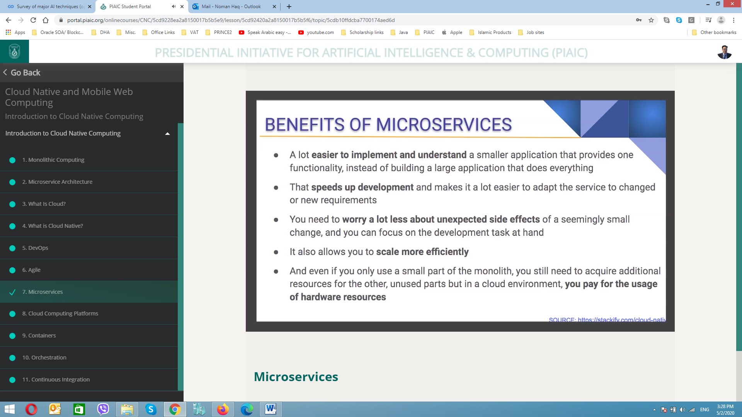

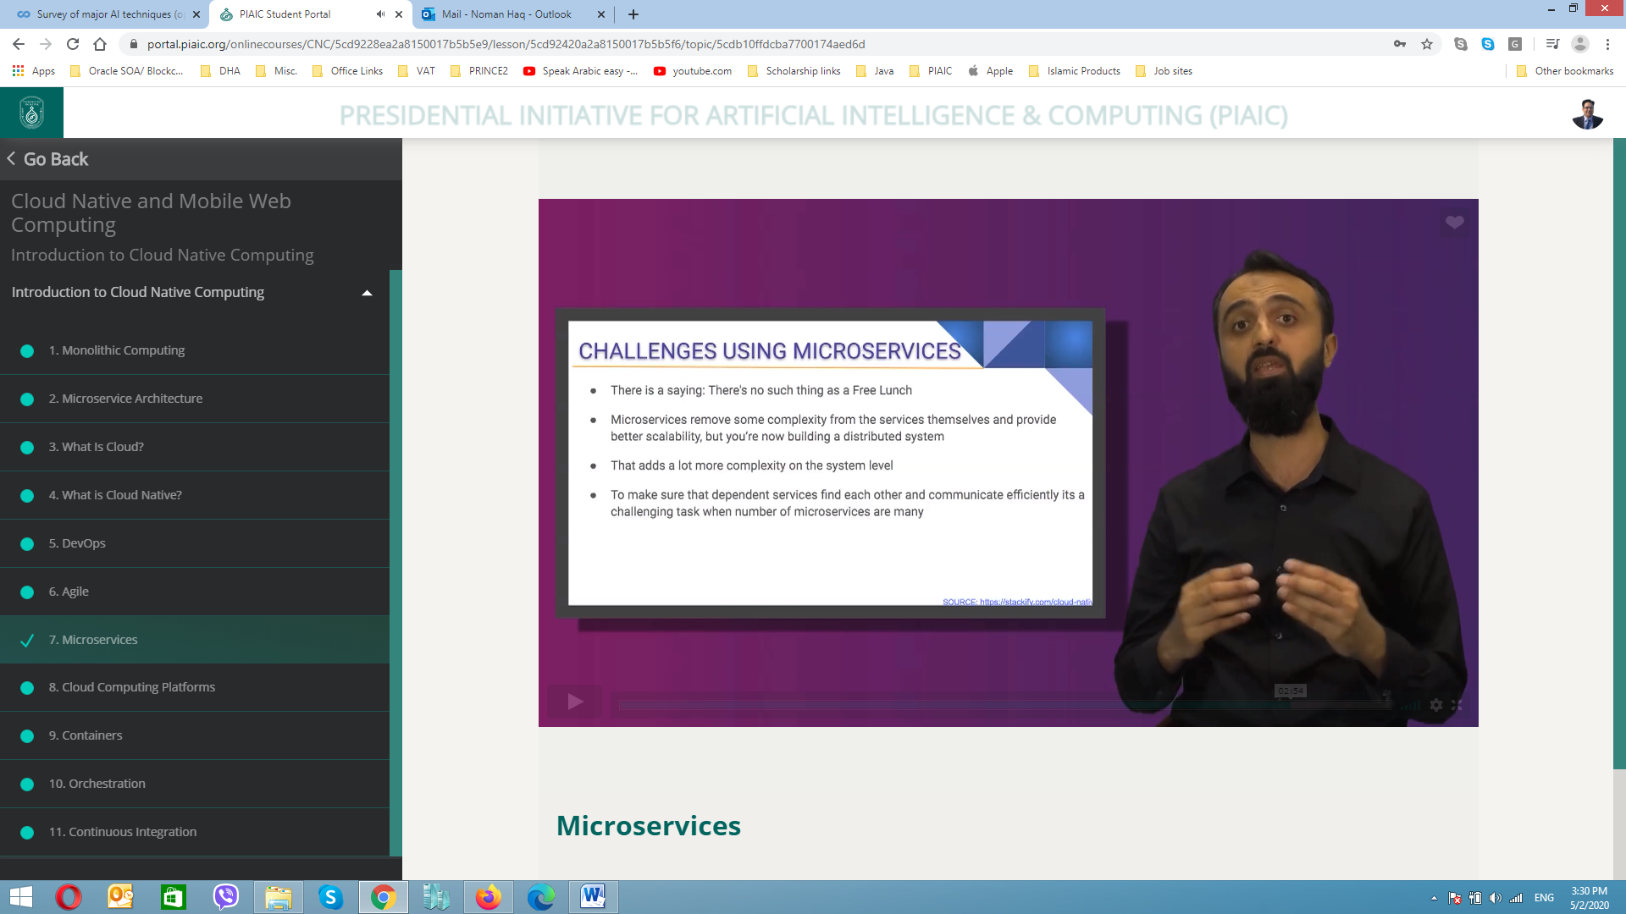

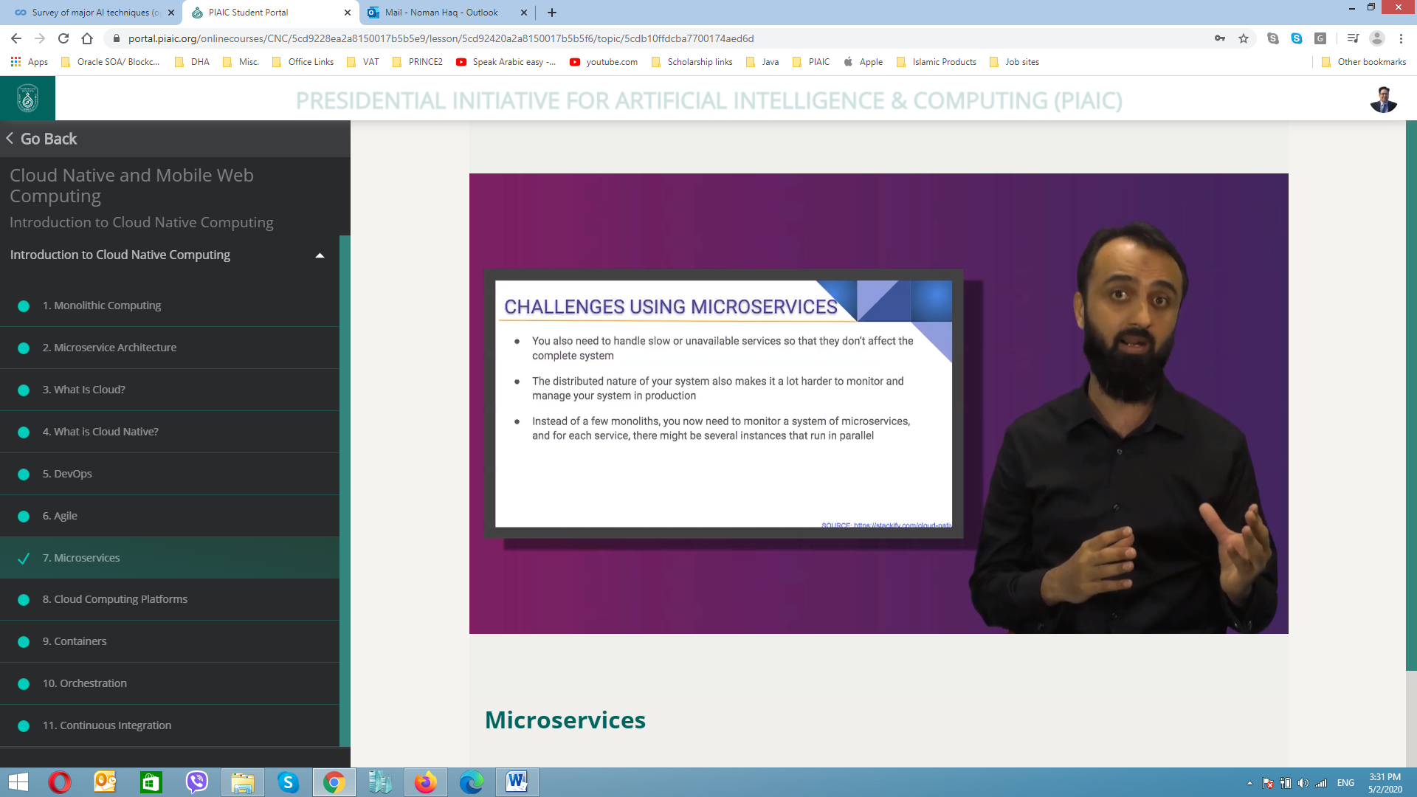

## Cloud computing platforms

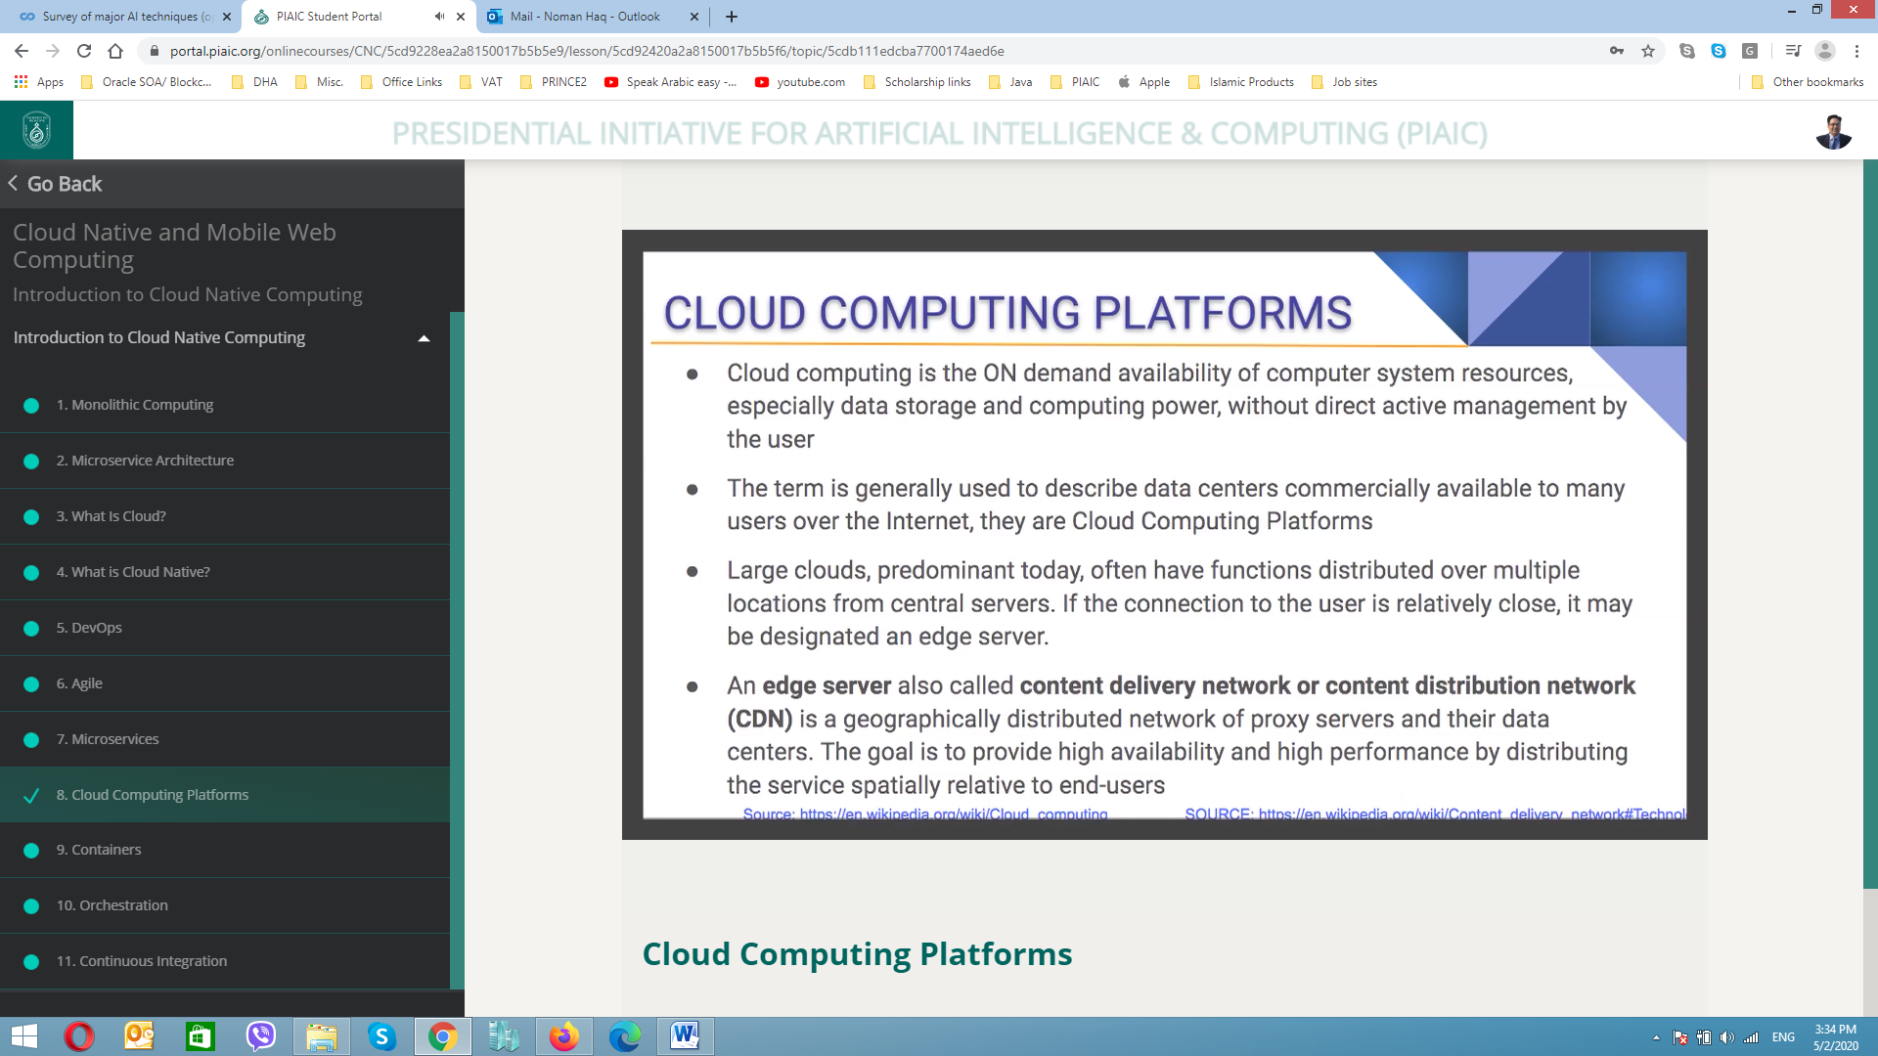

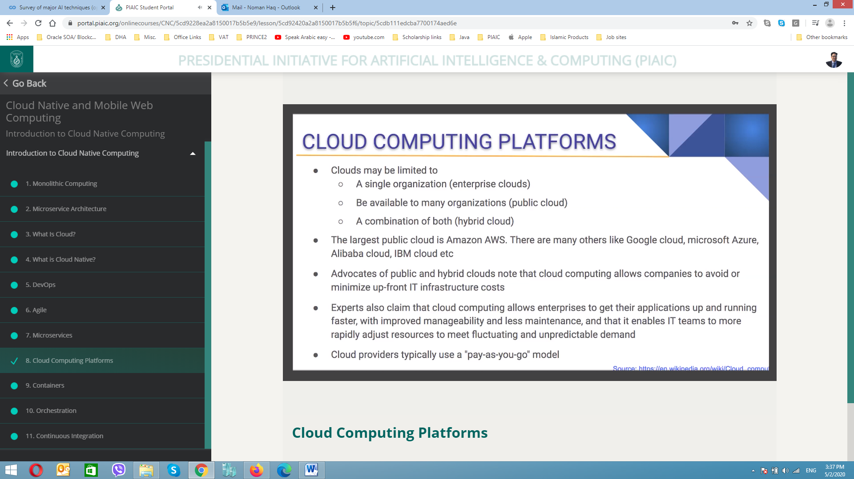

## Containerization

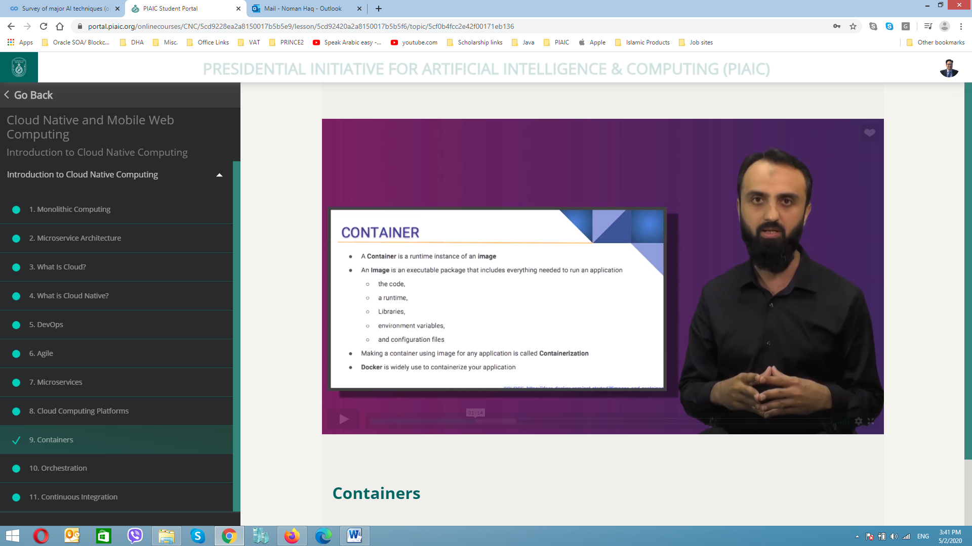

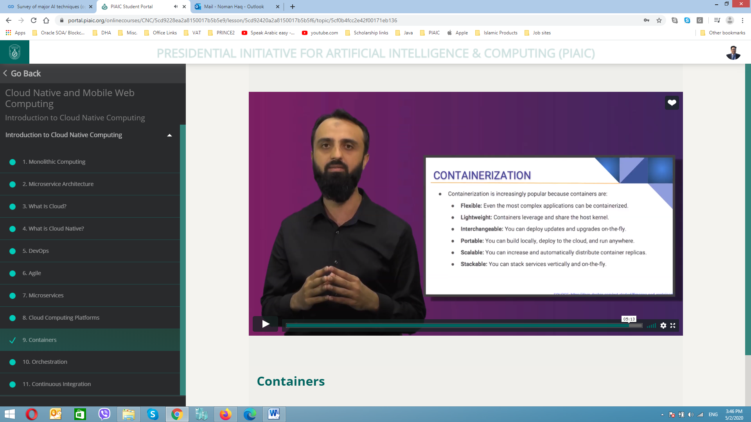

## Orchestration

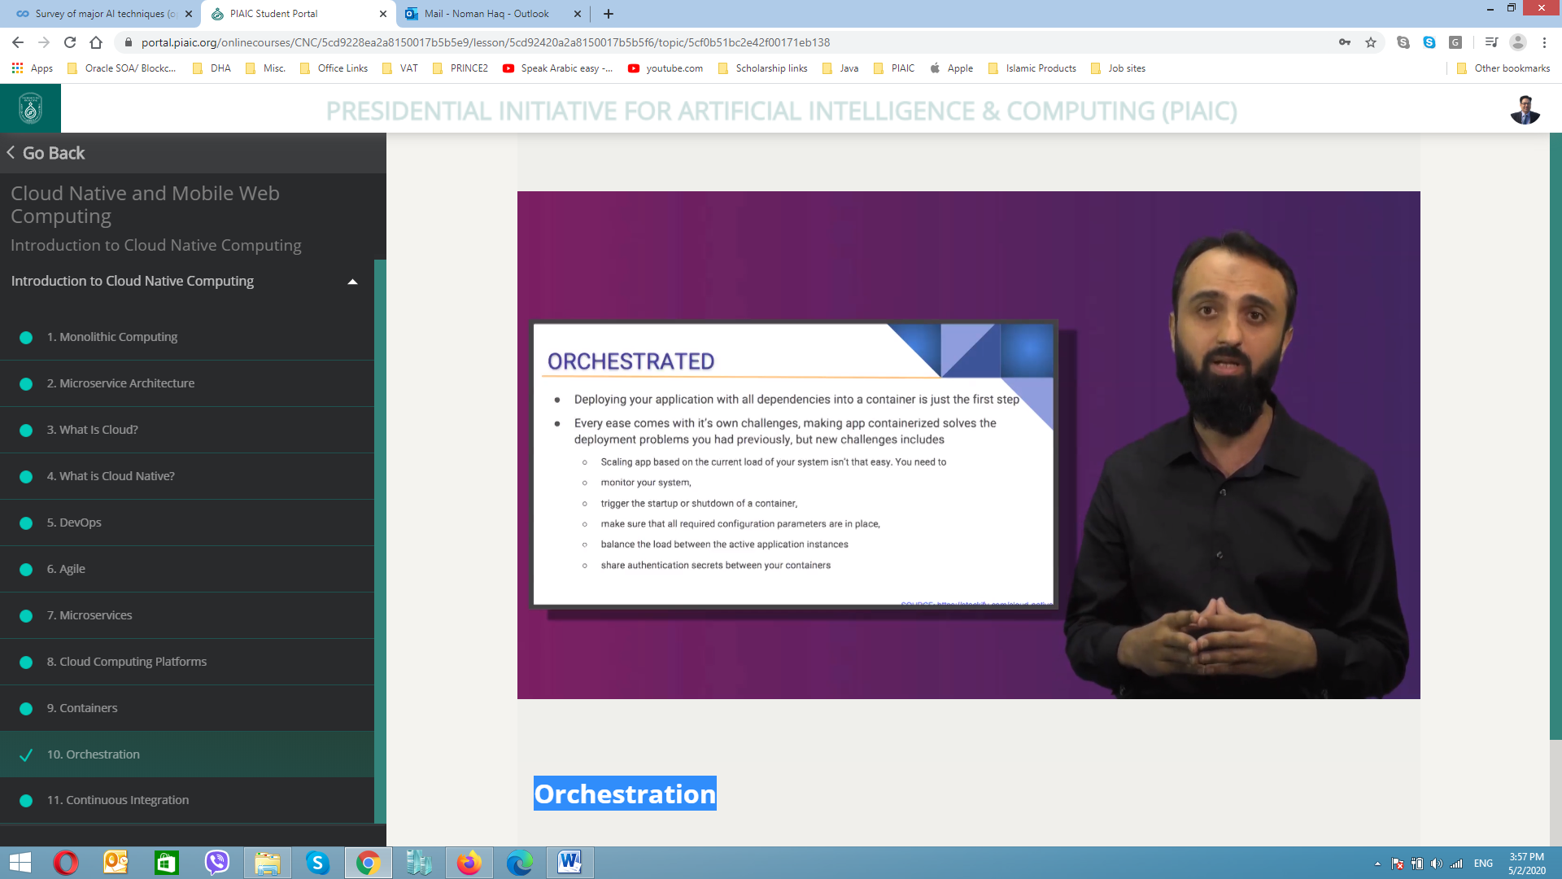

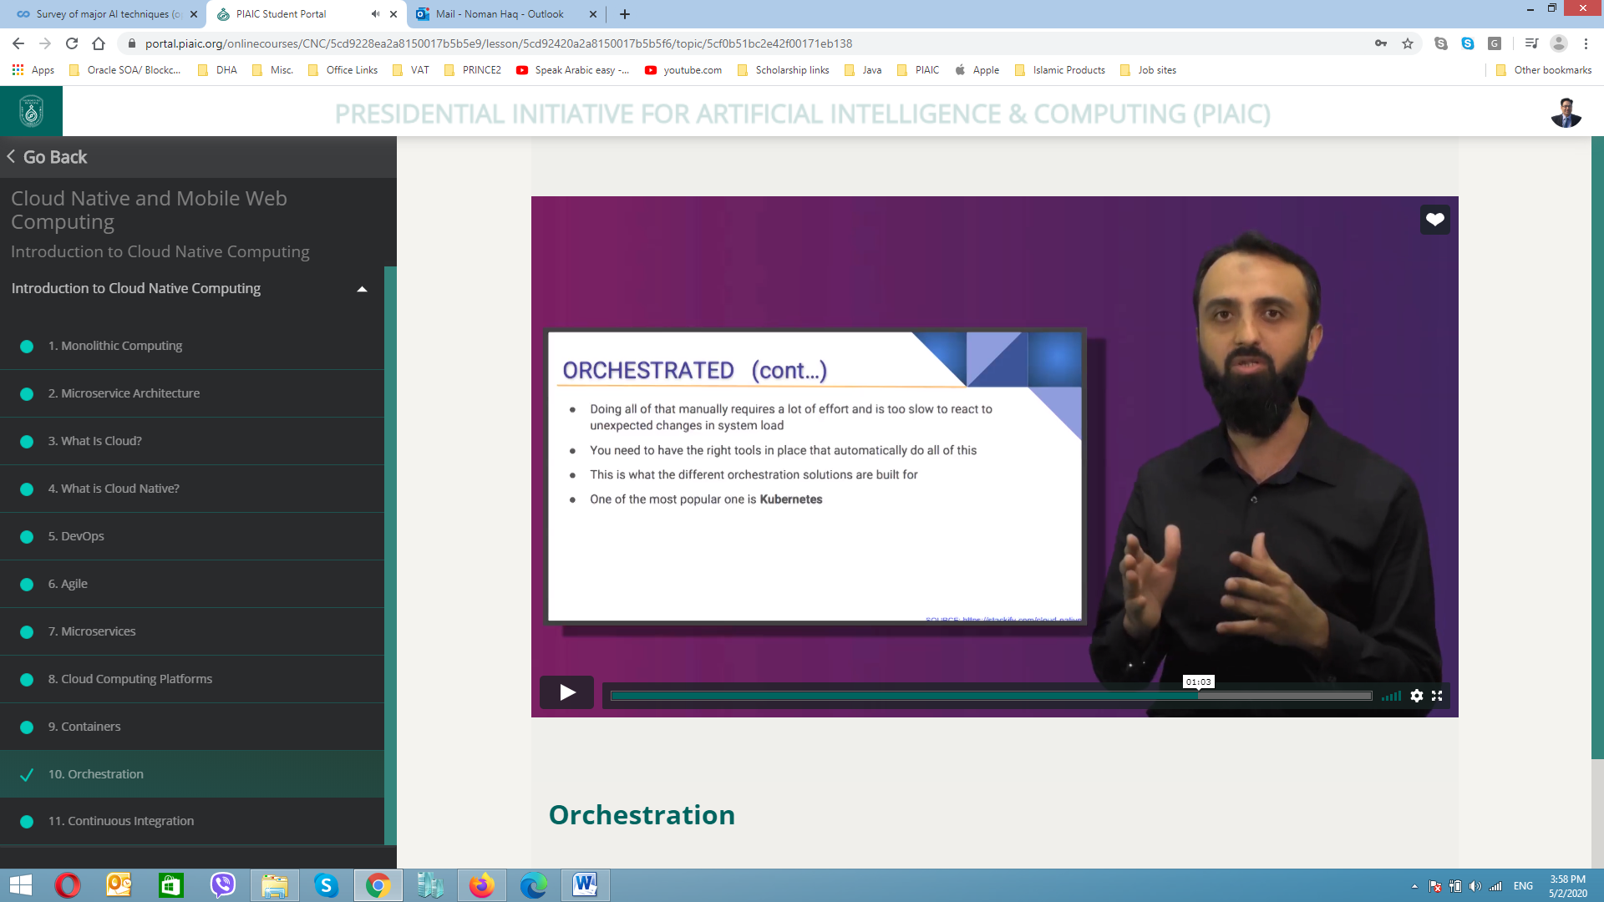

## Continuous Integration

